# Information Systems and Development Update Report

# R&GP Committee (May 2025)

### Introduction

Since the last report in February 2025, there has been good progress across a range of current projects and some exciting work on developing the requirements for future developments. During the period the systems have performed well and there have been no serious service interruptions or problems.

### System Upgrades

The Celcat timetabling and attendance system was upgraded to the latest version in February. This was the first upgrade in over 3 years and the first to be attempted by our new Devops Engineer James Reid. It went very smoothly

### New Student Funding System

The plan for the new Student Funding system is progressing. The suppliers ESS are consulting with the Scottish colleges who use Unit-e and are going to present a full plan and costed proposal in May. Based on this we will be developing an implementation plan to get everything configured, tested and deployed ready in Spring 2026 for the reception of student bursary applications for session 26-27

1. Project Progress

The table below gives a summary update on progress so far on the current projects this year so far

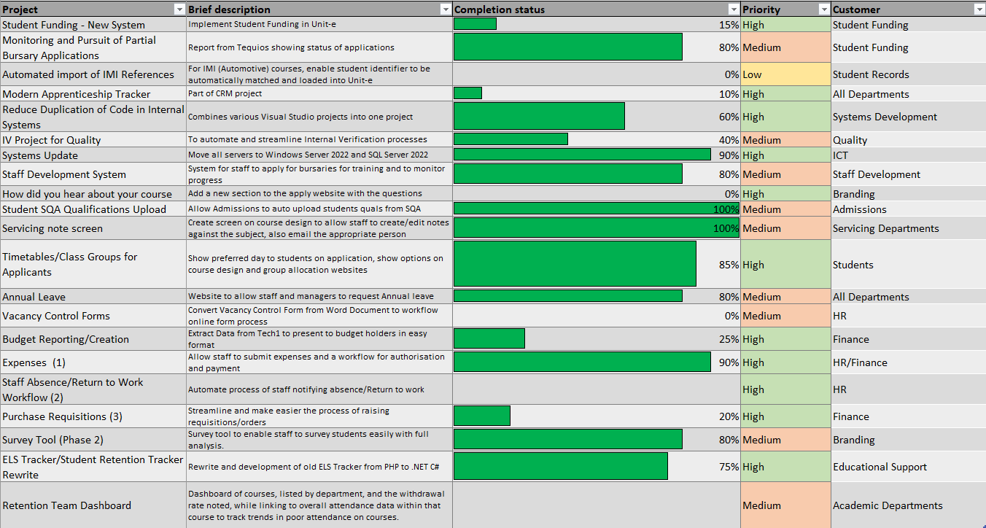Allan Forsyth

Head of Information Systems and Development