|  |  |  |  |
| --- | --- | --- | --- |
| **FOR DISCUSSION/INFORMATION** | | | |
| Meeting:  **RGP Committee – 18 November 2024** | | | |
| Presented by | **Ann Baxter** | | |
| Author/Contact | **Iain Clark** | Department / Unit | **Executive Board** |
| Date Created | **6th November 2024** | Telephone | **Ext 2321** |
| Appendices Attached | **Appendix 1 - Summary Financial Position Statement** | | |
| Disclosable under FOISA | | **Yes** | |
|  | |  | |

1. **PURPOSE**

To provide an Operational / Financial Summary Update on the Cumbernauld Campus Nursery.

1. **BACKGROUND**

As part of the Business Plan and related Governance, The Cumbernauld Campus Nursery Development Board (NDB) formally reports quarterly to the Finance Committee. Position Statements are to be sent monthly to Committee members and the College Executive Board. NDB Minutes are made available on The Clan.

1. **DETAIL**

The report includes updates on:

* 1. The NDB Meetings of 4th and 18th September 2024, 2nd and 30th October 2024.
  2. The Summary Financial Position.

1. **STRATEGIC IMPLICATIONS**

The Board retains an overview of NCL governance and progress against NDB Business Plan.

1. **RISK**

The Cumbernauld Campus Nursery is not performing to projections within the Business Plan.

1. **FINANCIAL IMPLICATIONS**

Possible financial exposure if not performing to forecast.

1. **LEGAL IMPLICATIONS**

Compliance with Nursery Legislation – The Education (Scotland) Act 1980, The Children

and Young People (Scotland) Act 2014, Regulation of Care (Scotland) Act 2001 – this

Act led to the formation of The Scottish Social Services Council (SSSC).

1. **WORKFORCE IMPLICATIONS**

There are no workforce implications at this juncture other than at operational levels.

1. **REPUTATIONAL IMPLICATIONS**

There are potential reputational implications if not compliant.

1. **EQUALITIES IMPLICATIONS**

There are no equalities implications.

|  |
| --- |
| **CONCLUSIONS/RECOMMENDATIONS**  The Finance Committee is asked to consider the information contained in this report and raise or discuss any issues. |

**Detail**

* 1. **Nursery Operational Update – September / October 2024**

Occupancy Update

Numbers are continuing to increase in all rooms. In terms of places, the 0 - 2, and 2 - 3 rooms are full and the 3 - 5 room is sitting at 57% at the moment. This will increase to 65% after the Christmas break. Looking at the whole nursery, 68% of places are filled and this will increase to 74% in January. There is a waiting list for both under 3 rooms. Children are also moving between rooms which is increasing occupancy in the 3 - 5 room, and the Nursery will be able to offer out places for the under 3 rooms on an ongoing basis.

Occupancy comparative based on places

|  |  |  |  |  |
| --- | --- | --- | --- | --- |
|  | Aug 23 | Jun 24 | Aug 24 | Oct 24 |
| 0 - 2 | 83% | 97% | 97% | 100% |
| 2 - 3 | 56% | 91% | 97% | 100% |
| 3 - 5 | 32% | 49% | 54% | 57%* |
| Whole Nursery | 40% | 59% | 63% | 68%* |
| *Increasing to 65% in term after Christmas  *Increasing to 74% in term after Christmas | | | | |

Funded Places

There are 3 intakes per year for Council funded places (August, January and April) therefore the Nursery will have new children starting throughout the year, or children who already attend (private funding) who will increase hours when they begin to receive Council funding. There will be a promotion of the Council funded places again between now and Christmas as all children who will turn 3 by the end of February 2025 will be entitled to a place in this academic year. There will be some parents who are still unaware of this, and the Nursery will be offering advice regarding start dates and completing the application, and using local social media to make everyone aware that places are still available. Children have transferred from 6 different local nurseries, and the Nursery is continuing to receive inquiries.

October Break

A total of 10 children attend during the October break, with a few parents of term-time children requesting extra sessions during this week. A relatively small number of parents had requested full year provision, but many of the children were enrolled, or already attended the nursery before the changes were made to the opening times and weeks in August this year. The Nursery expects the number of parents requiring full year provision to increase as the new opening times become established and especially after the applications for Council funding which will take place in January/February 2025 for the academic year 2025/26.

Curricular Interaction

The Nursery now has NC and HNC Childhood Practice students who have started placement in the nursery. There also courses starting in January which the Nursery has agreed to provide student placements for. The Nursery is working with the Sports Department to arrange some coaching sessions for the children, giving their students the opportunity to work with a younger age group.

Marketing

The Nursery is working with the marketing department to make a video which will showcase the nursery. Filming will take place on Wednesday 13th November, and the video will be completed before application forms for Council funded places for the 2025/26 session become available. There are plans to use the video and images on the college website, social media platforms, flyers, posters, media and press releases, educational resources and out-of-home advertising.

Toddler Dash Fundraiser

Nursery parents arranged for their children to take part in the local Toddler Dash event which took place at Broadwood Stadium in September along with a variety of running events for different age groups including the Cumbernauld 10k. They took along one of the Nursery banners and took the opportunity to promote the nursery by giving out leaflets and wearing their nursery t shirts. The parents raised an amazing amount of £1,085 for nursery funds, and also plan to use some of this money to buy food to donate to a local food bank.

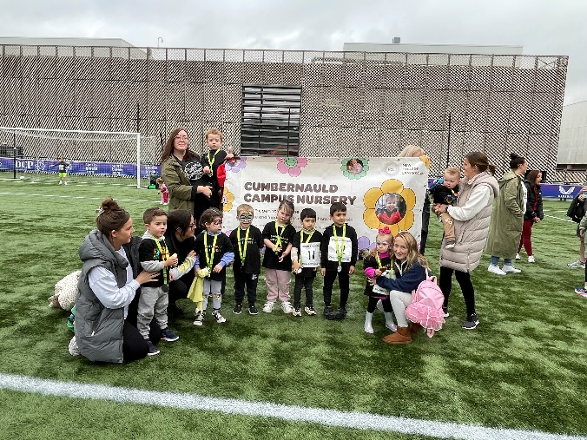

**1.2 Summary Financial Position**

As per Appendix 1, the Nursery has performed significantly better than budgeted for 2023/24 with a favourable variance of c£104k and a reduced operating deficit of c£73k against a budgeted deficit of c£177k. Inclusive of central costs of c£82k, it is a deficit of c£156k against a budgeted deficit of c£260k.

For 2024/25 full-year forecast, based upon current intake and applications, there is a small adverse variance forecast of £5k overall with an initial forecast operating surplus of c£56k against a planned surplus of c£61k. Inclusive of central costs (£78k against budgeted £85k), it is a forecast deficit of c£22k against a budgeted deficit of c£24k, a £2k favourable variance.

For 2024/25 year to date, based upon August & September figures, there is a small favourable variance of £3k overall with an operating deficit of c£14k against a planned deficit of c£17k. Inclusive of central costs (£13k against budgeted £14k), it is a deficit of c£27k against a budgeted deficit of c£32k, a £5k favourable variance to date.

The Nursery remains confident of bringing in the budget to plan through increased recruitment drives, enhanced marketing and further cost savings as the year progresses.

It should be recognised that the Nursery is only in the infancy of the revised operating hours and it will take time to fully become established in this market. The Nursery is continuing to receive applications and the staff are confident that the numbers will continue to increase, pulling in parents who specifically need the longer hours. The flexibility of the Council funded places continues to be promoted on the dedicated Facebook page, and the Nursery plans to offer temporary childcare during non-term-time weeks (October, Easter, Summer) to fill places, in turn attracting parents to the Nursery on a full-time basis.

*Iain Clark 06/11/24*