FOR DISCUSION/INFORMATION
Meeting: Curriculum and Student Affairs and Outcome
Presented by | Ann Baxter
Author/Contact | Ann Baxter | Department / Unit | SMT
Date Created | 9.2.23 | Telephone | 2359
Appendices Attached | New College Lanarkshire – Key Performance Indicator Update
Disclosable under FOISA |  | Yes

- PURPOSE
To update CSAO on the current credit position of New College Lanarkshire, and early learner withdrawal comparison rates.

- BACKGROUND
Report provided to CSAO to update on progress against targets within the Regional Outcome Agreement.

- DETAIL
The report shows current college performance and 4-year period of early withdrawals.

- BENEFITS AND OPPORTUNITIES
These infographics will enable staff to have a graphical visual representation of information, data, or knowledge to assist with understanding and accessing of information.

- STRATEGIC IMPLICATIONS
The Board retains an overview of NCL activity in the interests of good governance.

- RISK
N/A.

- FINANCIAL IMPLICATIONS
Inability to achieve KPI targets could result in loss of income to New College Lanarkshire.

- LEGAL IMPLICATIONS
There are no legal implications.

- WORKFORCE IMPLICATIONS
There are no workforce implications.

- REPUTATIONAL IMPLICATIONS
There are no reputational implications.

- EQUALITIES IMPLICATIONS
There ae no equalities implications.
CONCLUSIONS/RECOMMENDATIONS
CSAO are asked to note the information contained in this report and raise or discuss any issues which may prevent publication.

New College Lanarkshire – Key Performance Indicator Update

Curriculum, Student Affairs and Outcomes (CSAO) Committee

February 2023

Contents
NCL Credit Dashboard 4
Overview of Early Withdrawals 4
Withdrawal comparison – FEFT 6
Withdrawal comparison – FEPT 7
Withdrawal comparison – HEFT 8
Withdrawal comparison – HEPT 9

To access full interactive data:
Go to: https://infopoint.nclan.ac.uk/ then login using your NCLAN email address and password.
Or
Go to: Our web page at https://www.nclanarkshire.ac.uk/ then select “Staff Portal” at very top of page. Login using your NCLAN email address and password. You will then have access to the CLAN (NCL’s Intranet site) where you can access “infopoint“ and a whole range of other College resources.
If you require help with your Login please contact Diane McGill in the first instance Diane.McGill@nclan.ac.uk .

NCL Credit Dashboard

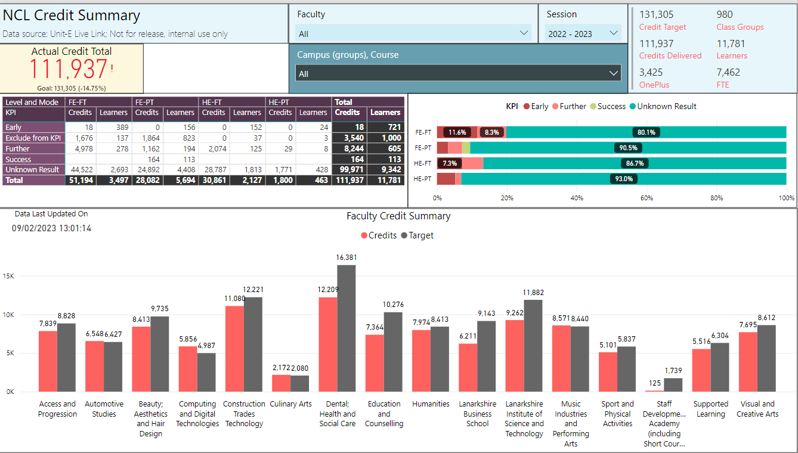

Overview of Early Withdrawals

Mode of Attendance | 2022 – 23 (in year) | 2021-22 | 2020-21 | 2019 - 20
FEFT | 11.6% | 13.8% | 9.8% | 11.92%
FEPT | 3.2% | 6.8% | 4.86% | 6.7%
HEFT | 7.3% | 7.2% | 5.39% | 6.11%
HEPT | 5.2% | 5.22% | 3.34% | 6.24%

SFC have not yet published College Performance Indicators 2021-22, and therefore it is not yet possible to benchmark the performance of NCL within the sector.

Withdrawal comparison – FEFT
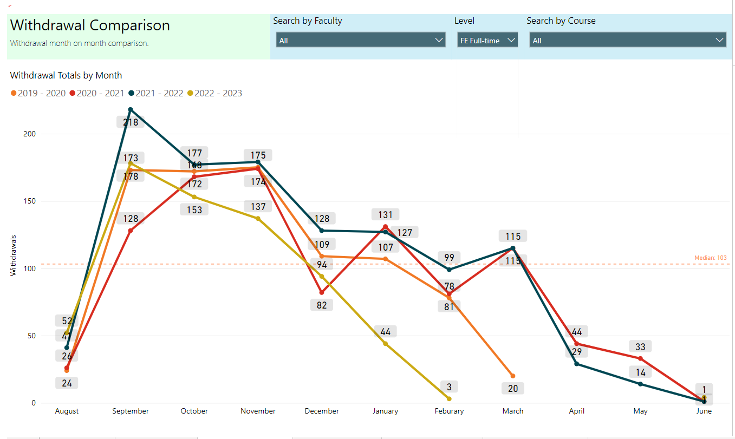

Withdrawal comparison – FEPT

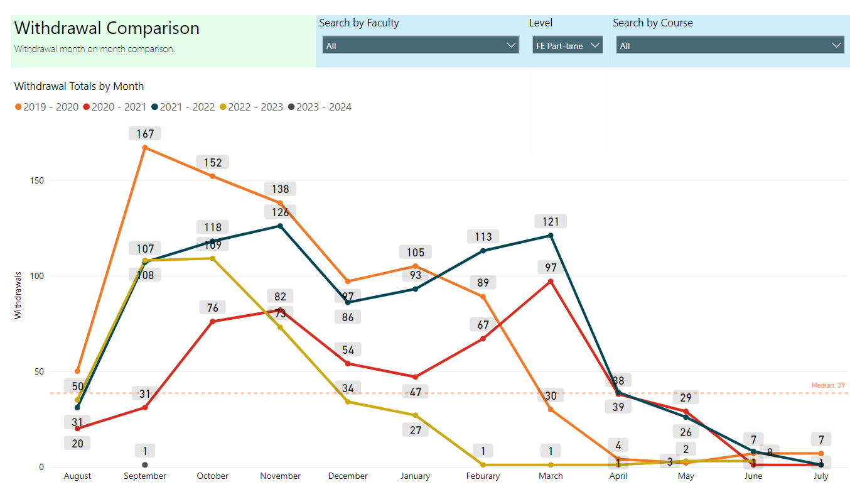

Withdrawal comparison – HEFT
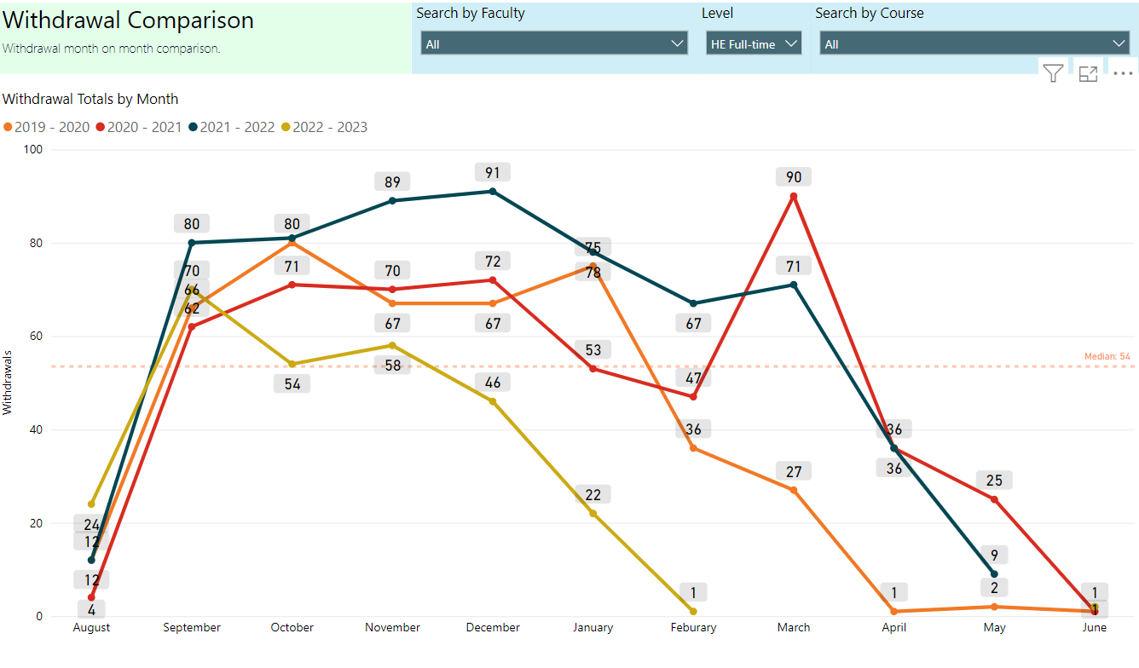

Withdrawal comparison – HEPT
