Intune Work Profile set up for iOS
- You need to download Intune Company Portal App, go to the App Store search for Intune Company Portal and install.
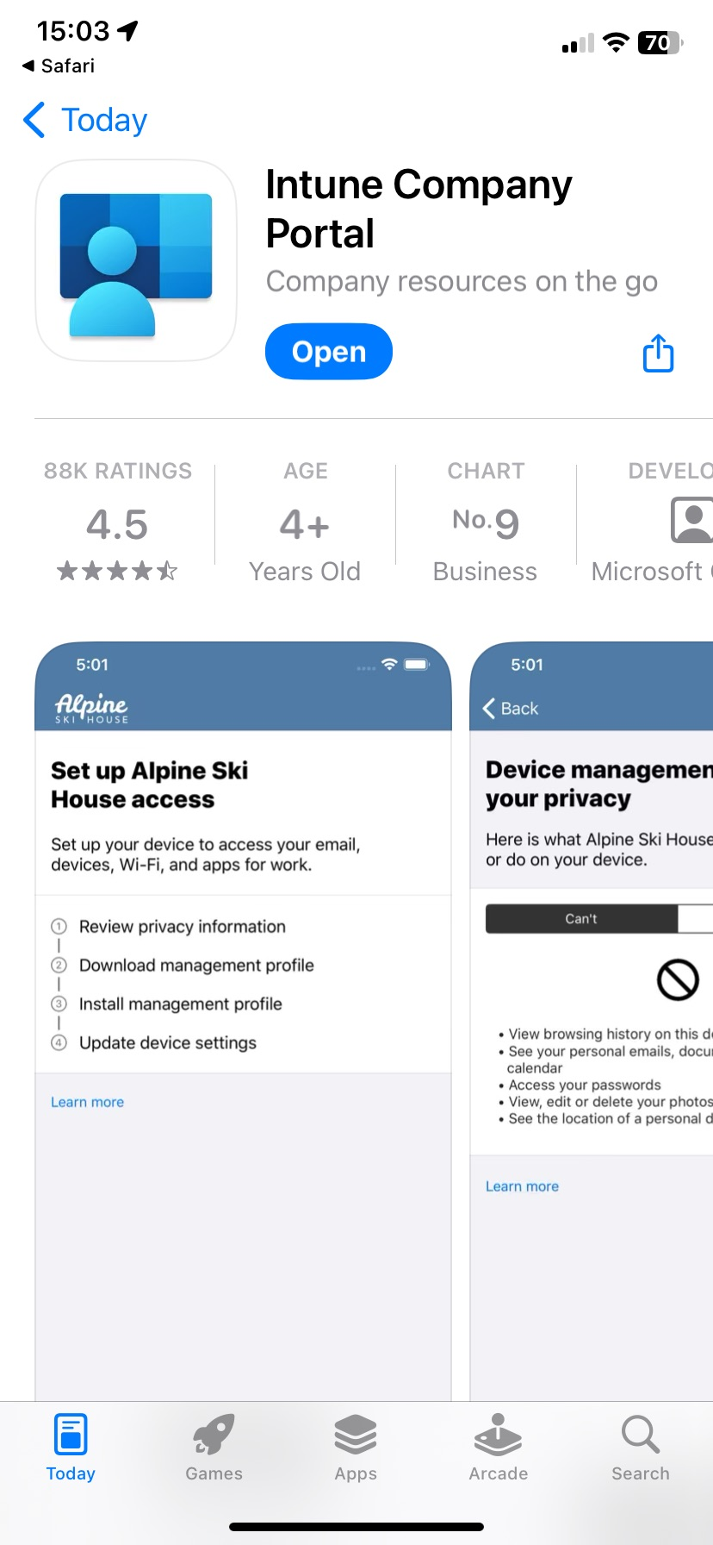

- Open the Company Portal app on your device and sign in with your work account.
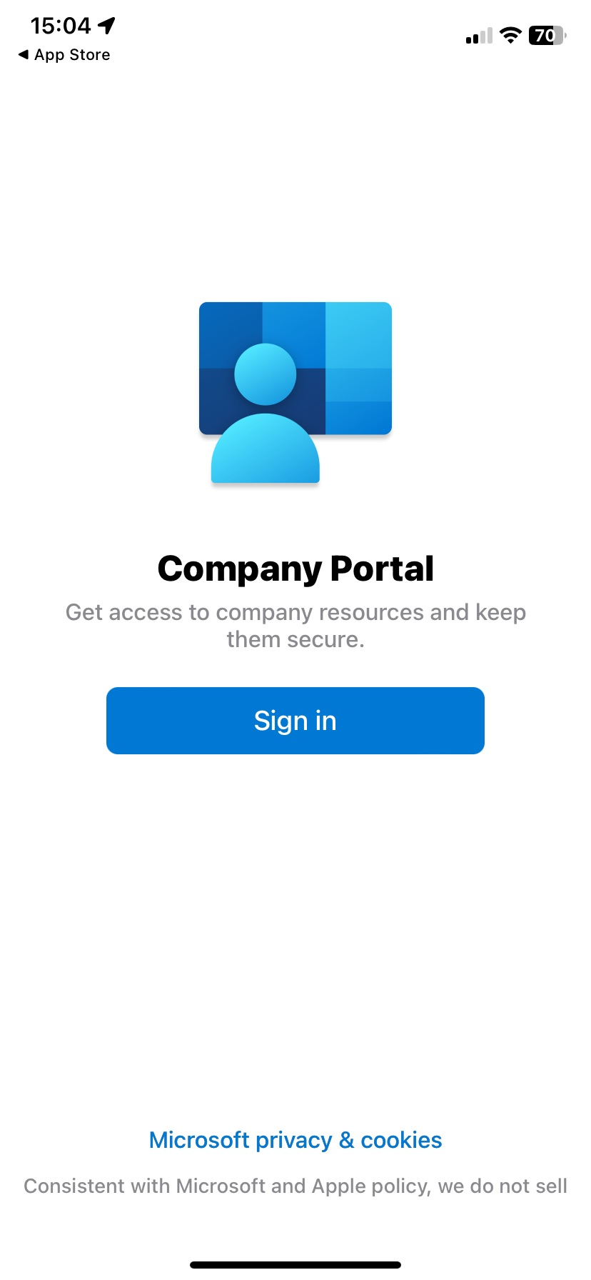

- When prompted to receive Company Portal notifications, tap Allow. Company Portal uses notifications to alert you of things you need to do to make your device more secure and maintain work access.

- On the Set up access screen, select Begin.

- Company portal will redirect you to download configuration profile. Tap Allow.

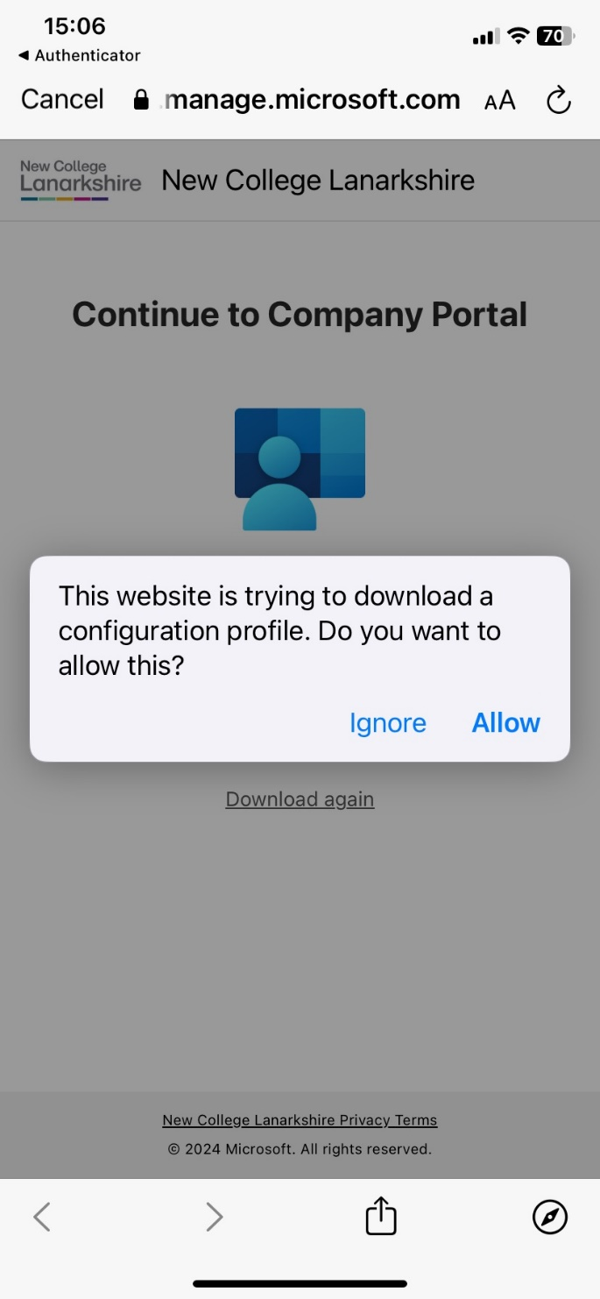
- After the download is complete, continue to Company Portal
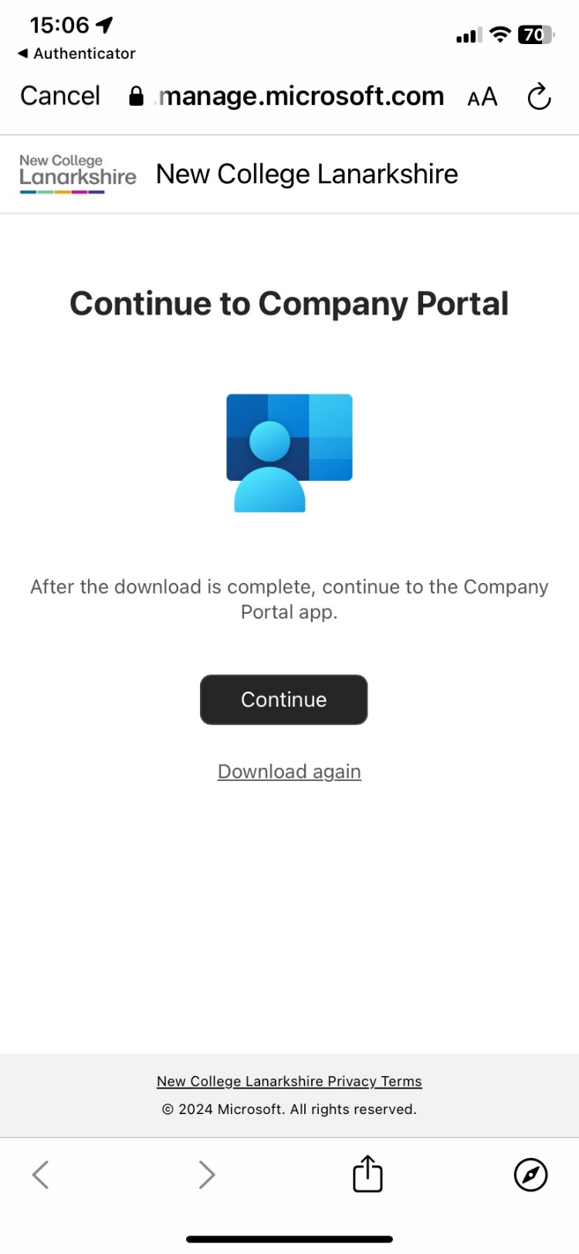

- In company portal you will find the instruction how to install configuration profile. As below, go to Settings > VPN & Device Management > tap Management Profile
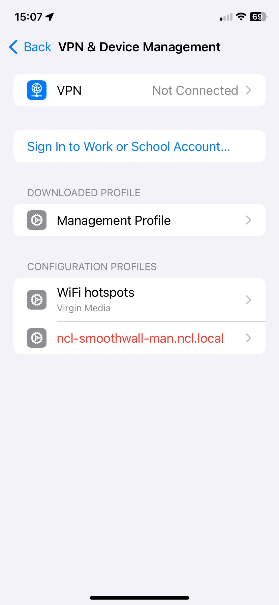
- Tap Install
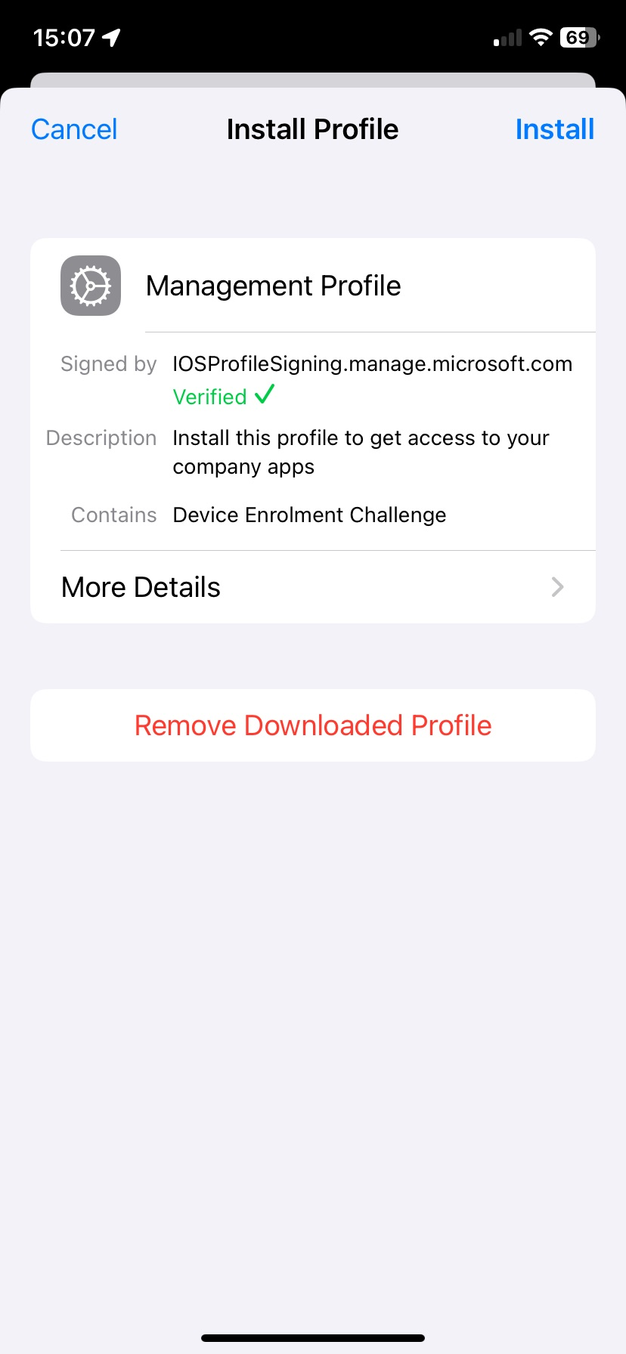
- Tap Install again
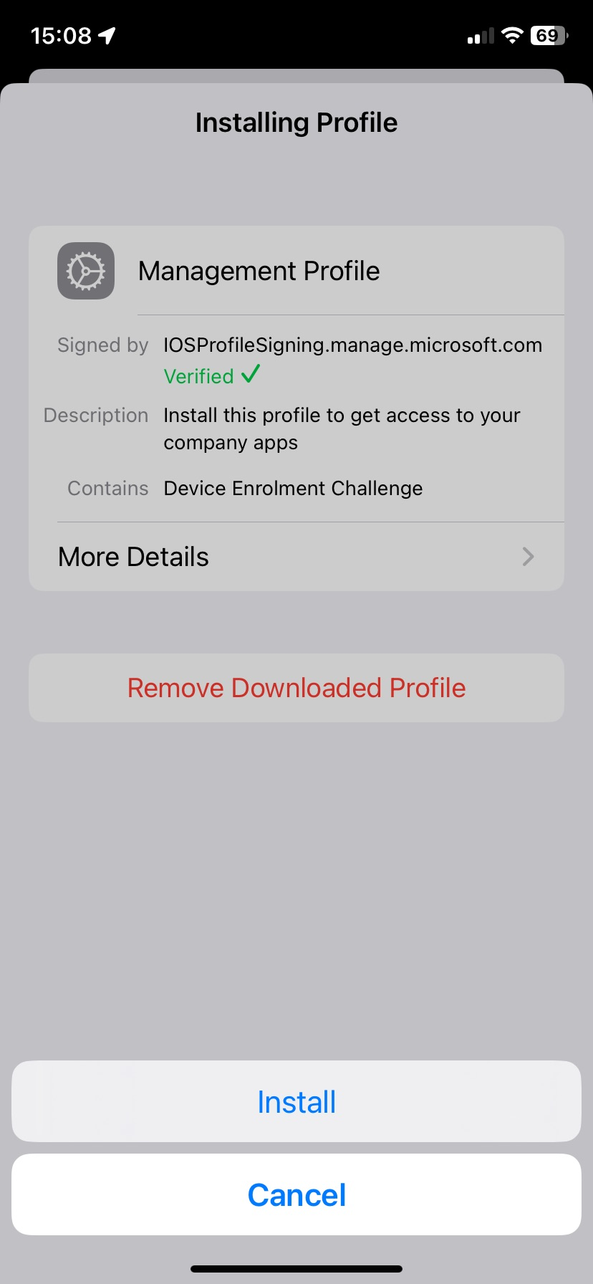
- Read the Warning and tap Install
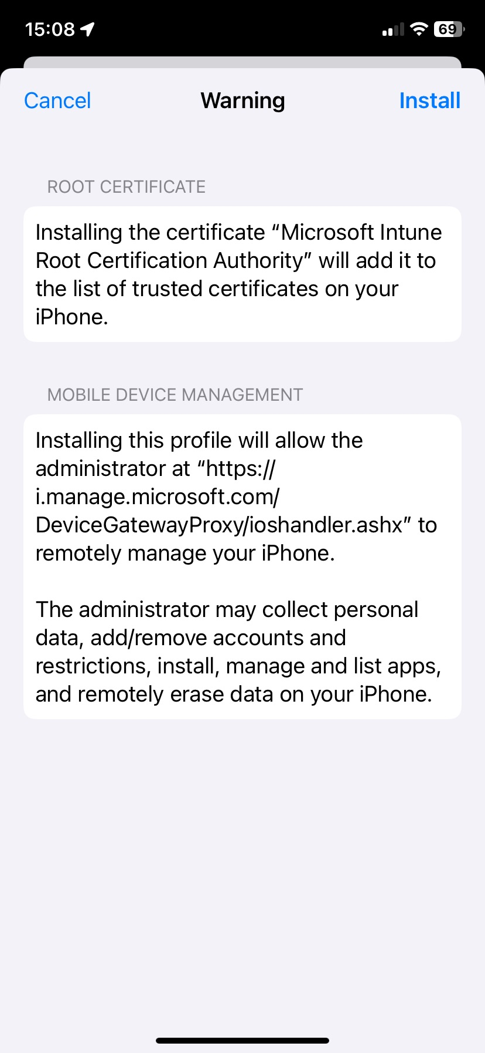

- Tap Done
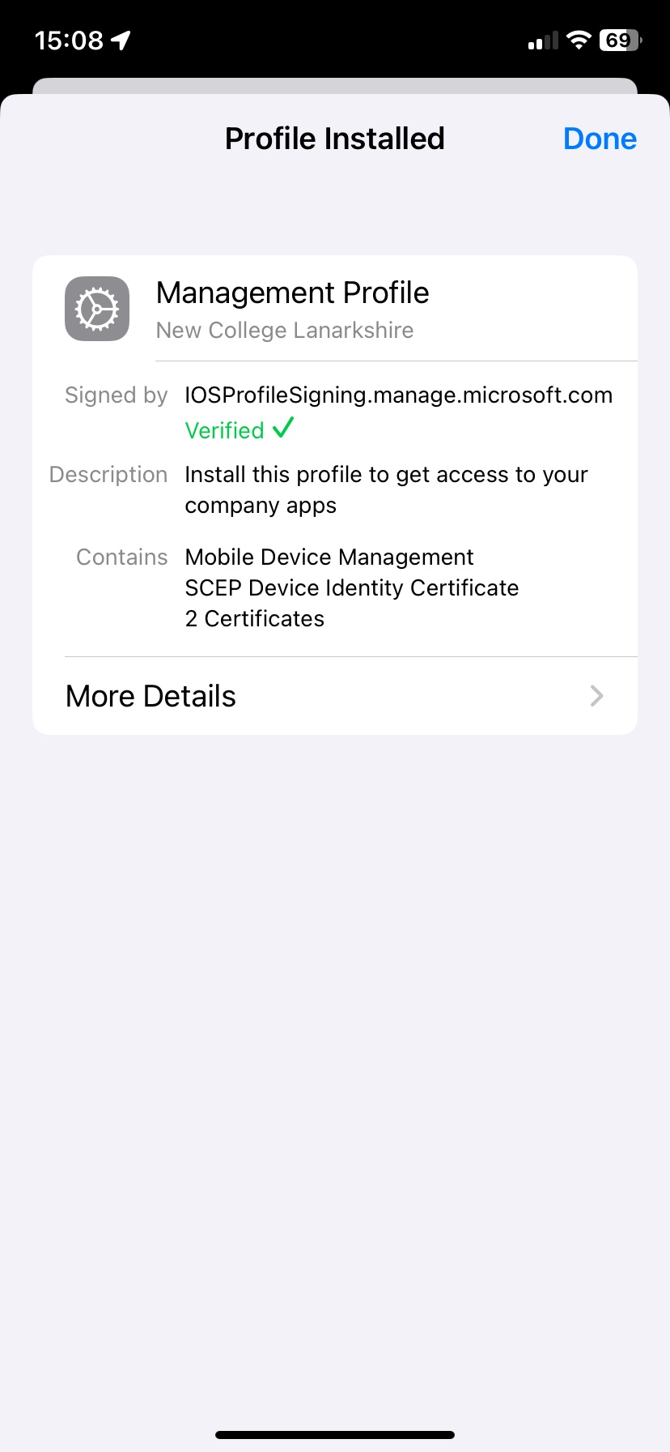
- Go back to the Company Portal App, you can see that your device settings are being checked.
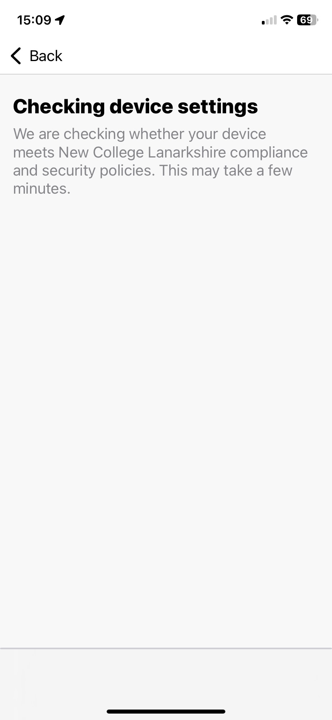
- Your passcode/password must be 8 digits long, if your passcode/password does not meet this criteria it must be changed as below.
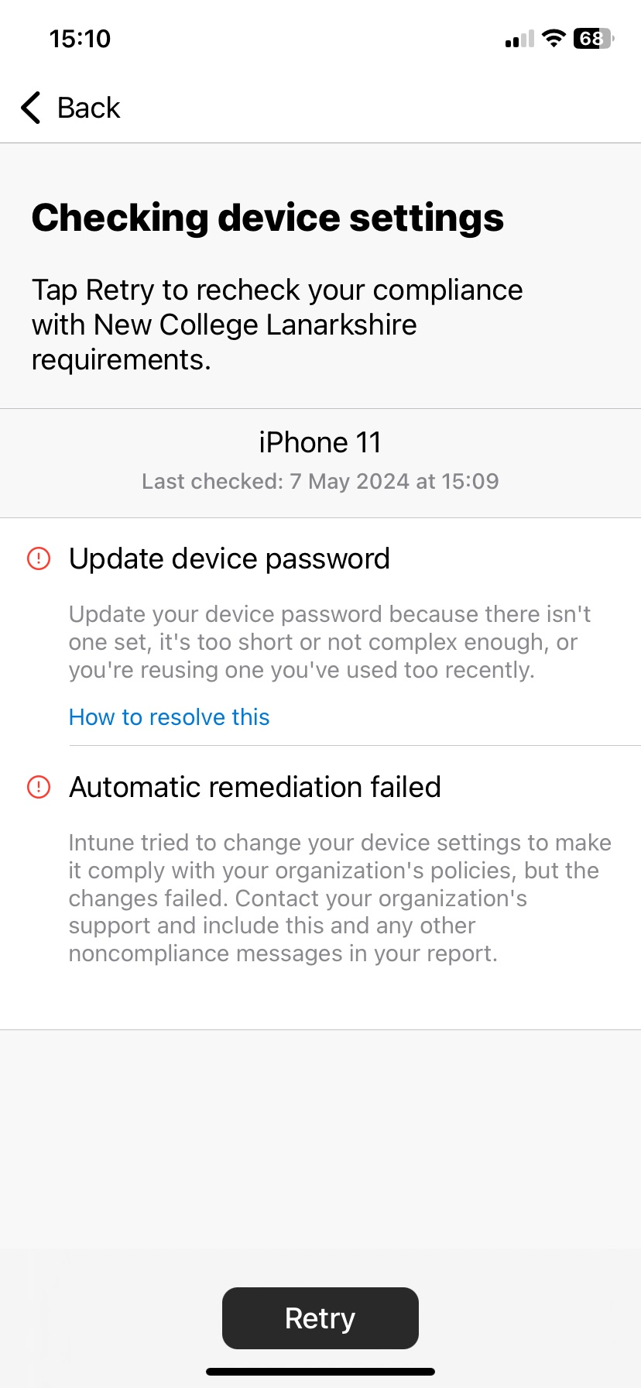
- Exit Company portal, in passcode change prompt tap Change Now
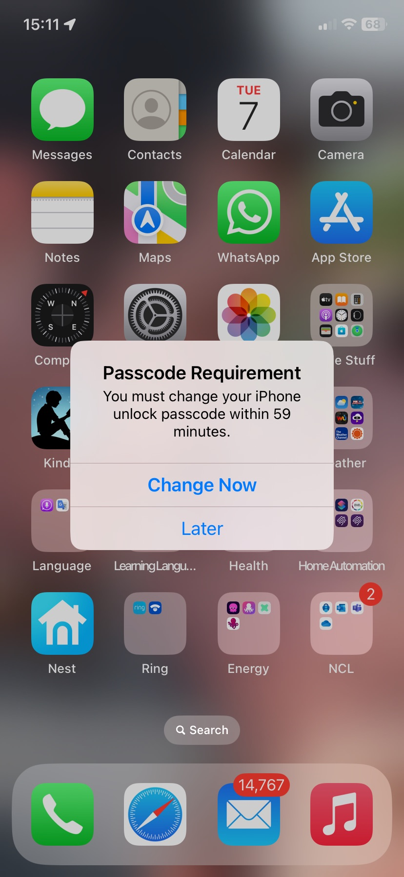
- Set up new passcode and confirm your new passcode.
- Your Work Account is now ready. You can download and use work apps like Outlook, Teams, OneDrive on your phone.

