**POLCFO 4 Delegated Financial Authority Policy**

**FIN01.2 – Delegated Financial Authority Policy**

All College policies and procedures adhere to the guidelines and ethos of Equality and Diversity

When printed this document becomes

**UNCONTROLLED COPY**

Always refer to the Intranet to ensure you are accessing the current version.

|  |  |  |  |  |
| --- | --- | --- | --- | --- |
| **Date Origin** | **Last Review** | **Next Proposed**  **Review Date** | **EQIA Date** | **Responsibility for Review** |
| April 1999 | January 2025 | August 2025  Subject to updated Financial Memorandum | January 2025 | Chief Resources Officer/Financial Controller |

**Contents**

1. Introduction 3
2. Scheme of Delegation 3
3. Linked Policies/Related Documents 8

Appendix A – SFC Delegated financial limits and annual reporting requirements for

Regional Colleges and Regional Boards 9

Appendix B – Specific Delegated Financial Authorities 10

Version Control 11

# **Introduction**

The financial procedures enable the transfer of delegated authority from the Board of Management to the Principal & Chief Executive and to members of the Executive Board (EB), Deans, Heads of Department, Heads of Professional Services and other staff within the College. This enables the College to increase effectiveness through:

* streamlining decision-making
* allowing greater flexibility on the use of funds
* motivating and incentivising staff to maximise the return from their funds whilst maintaining sound financial controls.

Delegated Authority is the financial limits that are assigned to individuals within the College regarding their ability to approve new projects and to commit and approve expenditure. On agreement of the annual Revenue and Capital Budgets, authority is delegated from the Principal to the Executive Board (EB) and Budget Holders in line with procurement and purchasing levels granted to each Budget area. This is also reflected in the Technology One system. By signing the Delegated Authority Form, members of staff are acknowledging that they have read and understood the Financial Procedures and that they will use their delegated authority both appropriately and responsibly.

# **Scheme of Delegation**

The Scheme of Delegation sets out the levels for authorisation of Delegated Authority Limits.

1. matters not delegated by the Scottish Funding Council

2. matters reserved for the Board of Management

3. delegations to the Chair of the Board

4. delegations to the Principal & Chief Executive

5. delegations to members of staff via the College’s Budgeting and Purchasing

Procedures

These are specified in the sections, below.

* 1. **Matters not delegated by the Scottish Funding Council (SFC)**

With FE Colleges receiving a substantial portion of their overall income from the Scottish Funding Council, the uppermost level in the scheme of delegation is not the Board of Management but, rather, the SFC. Therefore, this section should be read in conjunction with the updated Financial Memorandum (effective 01 December 2014), which sets out the formal relationship between SFC and fundable bodies and sets out the requirements with which fundable bodies must comply as a condition of grant from SFC.

Link: [Financial Memorandum with the College Sector - 1 December 2014](https://www.sfc.ac.uk/wp-content/uploads/uploadedFiles/Financial_Memorandum_with_the_College_Sector_-_1_December_2014.pdf)

The following financial matters have not been delegated by the Scottish Funding Council (SFC). Financial matters are also subject to the Scottish Public Finance Manual (SPFM) & UK Public Sector Financial Reporting Manual (FReM):-

a) Capital Finance – All borrowing by incorporated Colleges will require the approval of Scottish Ministers. Requests to borrow must be submitted to SFC in the first instance. Regional Boards may not borrow money.

b) Estates

* The College must obtain prior SFC approval before initiating the sale of any exchequer funded asset over £500,000.
* The College must obtain prior SFC approval before retaining the sale proceeds of any exchequer funded asset over £500,000.
* The College must obtain prior SFC approval before entering a lease for a period of 5 years duration or more.
* The College must obtain prior SFC approval before transferring any title or granting any interest or licence in land or building which were acquired or developed in whole or in part using exchequer funds. Similarly, institutions must obtain SFC consent if they intend to offer as security, for any loan, any asset which has been provided, improved or maintained with the aid of SFC grant monies.

c) The College must obtain prior SFC written approval if it intends to lend or give a guarantee, indemnity or letter of comfort (except in the regular course of business – e.g. procurement contracts).

d) The College must not make any Investments of a speculative nature without prior written approval of SFC.

e) Prior SFC approval must always be obtained before incurring expenditure for any purpose that is, or might be considered, novel, contentious or repercussive or which could have significant future cost implications.

* 1. **Matters Reserved for the Board of Management**

As per the Board of Management Constitution and Articles of Governance, the following financial matters are reserved for the Board of Management and, therefore, excluded from delegation:

* the final approval of the annual Budget for income and expenditure and capital expenditure for work authorised by the Board;

1. the disposal of heritable property;
2. the acceptance of donations, endowments, gifts of money, land or other property and determining their application to, or setting up a trust or foundation, to hold and administer them for the purpose of carrying on any of the activities which the Board have to carry on;
3. expenditure on any single contract item greater than £100,000 (excluding VAT) where SFC have made a Capital Contribution Grant.
   1. **Delegations to the Chair of the Board**

As per the Board of Management Constitution and Articles of Governance, the following financial matters are delegated to the Chair of the Board;

1. within any guidelines set by the Board, to incur expenditure to meet the expenses of the office of Chair of the Board on the provision of reasonable hospitality to representatives of other Colleges, organisations and others;
2. to sign and date the Report of the Board on the Annual Accounts in terms of the accounts direction given by the Scottish Funding Council, under the Further and Higher Education (Scotland) Act 2005.
   1. **Delegations to the Principal & Chief Executive**

As per the Board of Management Constitution and Articles of Governance, the following financial matters are delegated to the Principal & Chief Executive, or in the absence of the Principal & Chief Executive, the Deputy Principals, subject to appropriate approval having been made by the Board for the current year:

1. develop financial policies and operational procedures that, as a minimum, comply with SFC and SPFM instructions and delegations; relevant laws and regulations; and any policy matter as specified by the Board of Management;
2. operate the finances of the College within these financial policies and procedures;
3. administer in accordance with any policy of the Board, the provision to students of the College of financial or other assistance;
4. set and amend as necessary the level of tuition fees, examinations expenses, maintenance and contribution scales for all courses offered by the College and to waive or grant remission of fees and expenses in special cases within guidelines set by the Board;
5. provide financial and other assistance to the Students’ Association of the College within the terms of any scheme of establishment or policy of the Board;
6. grant the use of College accommodation to outside bodies or persons, for the purpose of holding meetings and functions, on such terms and conditions as are reasonable in the circumstances;
7. arrange for any necessary alterations or adaptations to college property at a cost of up to £100,000 in respect of one project, provided the alteration or adaptation does not affect any material change in the character of the College;
8. seek and receive tenders for contracts with the Board, and when competitive tenders are sought, to open the tenders electronically through a secure tender portal;
9. after all necessary approvals have been obtained, enter into contracts on behalf of the Board or to authorise another to enter into contracts on behalf of the Board;
10. when it is in the interest of the Board to do so, terminate contracts or authorise the termination of contracts;
11. check the financial standing of potential contractors;
12. Enter into contracts for the supply of goods, services and works aligned to Appendix B - Specific Delegated Financial Authorities and sign such other contracts of higher value as already approved by a Committee of the Board or the Regional Board;
13. dispose of assets which are surplus to requirements to the value of £15,000 provided that asset is not land, buildings or other structure or an interest in land, buildings or other structure;
14. enter into arrangements for leasing of land/or premises when the rental does not exceed £100,000 per annum and to sign agreement forms for such leases with notification given to the Board of Management;
15. enter into arrangements for rental, hire or leasing items of equipment when the rental or hire charge for any single item does not exceed £100,000 per annum and to sign agreement forms for such rentals, hires or leases and for rentals, hires or leases approved by a committee or the Board;
16. provide courses as requested by outside agencies and to negotiate appropriate charges thereof;
17. administer any educational endowment which transferred to, and vested in, the Board in terms of the Further and Higher Education (Scotland) Act 2005;
18. raise funds for, and apply them to, any of the activities which the Board has the power to carry on;
19. sign cheques/bank transfers on behalf of the Board;
20. take out any necessary insurance to protect the interests of the Board;
21. settle up to a maximum of £50,000, and without reference to the Board, claims made against the Board where there is no insurance and whether or not a court action has been raised, subject to any necessary approvals being obtained when Treasury Indemnity applies;
22. make arrangements with insurance companies concerning the settlement of claims;
23. on receipt of valid claims, pay to members of the Board, such allowances and expenses as the Board has determined;
24. on receipt of valid claims, pay to members of the Board’s committees (whether or not they are also members of the Board), such allowances and expenses as the Board have determined.

**The functions listed in this section are delegated to the Principal & Chief Executive and may be exercised by a member of staff nominated by the Principal. In exercising any delegated function, the authorised member of staff will take account of any appropriate departmental practice, of any Executive or Managerial instruction of any other similar consideration. The leasing of land and premises cannot be delegated below EB level.**

**2.5 Delegations to Members of Staff via the College’s Budgeting and Purchasing Procedures**

The Board of Management approves the College’s annual budget of income and expenditure (and the six-monthly forecast exercise).

The College budget is compiled from the budgets of the individual cost centres and the Principal & Chief Executive, via the appropriate Deans, Heads of Department and Professional Services Heads/Managers, nominates a Budget Holder for each individual cost centre who then becomes responsible for controlling the approved budget.

Within the approved budgets, and subject to the purchase order procedures and purchasing procedures, purchasing authority is delegated as follows:

1. A member of staff acting in a staff role can request that a Purchase Order be raised;
2. The Purchase Order can only be authorised by the designated Budget Holder;
3. Budget Holders should set a delegation on the Finance software for periods of planned absence;
4. In the absence of a Budget Holder, Purchase Orders can be only approved by the Deputy Principals, Financial Controller, or the Chief Resources Officer;
5. Invoices can be authorised for receipt and payment by any member of staff who is in a position to confirm the authorising requirements.

See separate Purchasing Policy and Procedure for further detail.

# **Linked Policies/Related Documents**

3.1 Purchasing Policy (PROCFO 11)

3.2 Purchasing Procedure (PROCFO 11.1)

3.3 Procedure for Online Purchases & use of College Purchases Card (PROCFO 2.1)

3.4 Board of Management Articles of Governance

3.5 Donations and Gifts Acceptance Policy (POLCFO 7)

3.6 Donations and Gifts Acceptance Procedure (PROCFO 7.1)

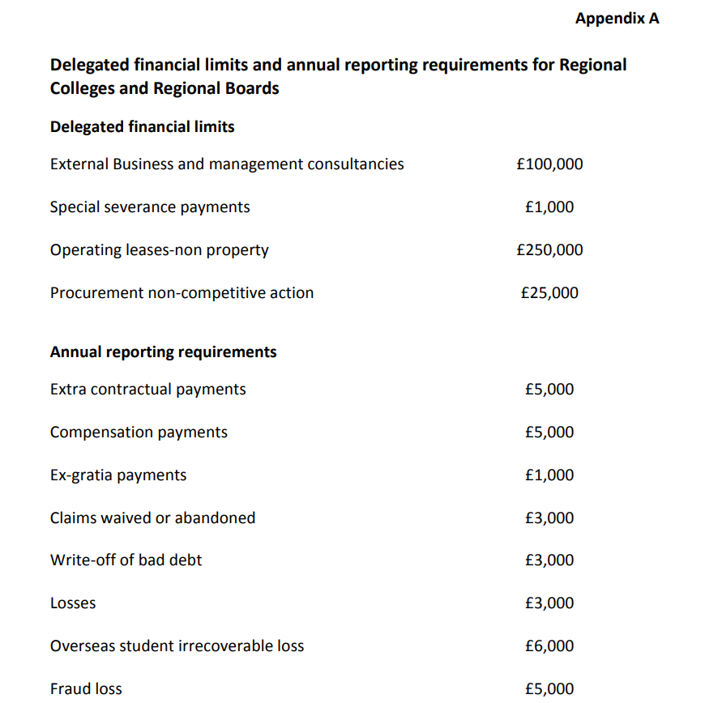

**Appendix B – Specific Delegated Financial Authorities**

|  |  |  |  |
| --- | --- | --- | --- |
| Goods & Services | | | |
| Total Contract Value (Ex VAT) | **Action** | **Responsibility** | **Contract Authorisation** |
| <£5000 | Normal Purchasing Procedure | Department | The Budget Holder |
| £5000 - £9999 | Value for Money Exercise | Department | The Budget Holder |
| £10,000 - £49,000 | Three Formal Quotations via Public Contract Scotland (PCS*), or email | Department | The Budget Holder & Financial Controller / Senior Accountant |
| £50,000 - £100,000 | Low value Regulated Tender via PCS | Procurement | EB Member and Chief Resources Officer / Senior Accountant |
| £100,000 - £250,000 | Low value Regulated Tender via PCS/High Value Regulated Tender | Procurement | EB Approval/Principal Sign Off |
| £250,000 - £800,000 | High Value Regulated Tender | Procurement | EB/Finance Committee Approval |
| >£800,000 | High Value Regulated Tender | Procurement | The Regional Board |
| Works | | | |
| Total Contract Value (Ex VAT) | **Action** | **Responsibility** | **Contract Authorisation** |
| £10,000 - £50,000 | Three Formal Quotations via Public Contract Scotland (PCS), or email | Department | Head of Estates |
| £50,000 - £250,000 | Three Formal Quotations via Public Contract Scotland (PCS), or email | Department/  Procurement | Chief Resources Officer/EB & Head of Estates |
| £250,000 - £800,000 | Three Formal Quotations via Public Contract Scotland (PCS), or email | Department/  Procurement | Principal/Finance Committee |
| >£800,000 - £2,000,000 | Three Formal Quotations via Public Contract Scotland (PCS), or email | Department/  Procurement | Principal/Finance Committee |
| £2,000,000 - £4,447,447 | Low value Regulated Tender via PCS | Procurement | The Regional Board |
| >£4,447,447 | High Value Regulated Tender  via PCS/GPA* | Procurement | The Regional Board |

*PCS – Public Contracts Scotland, regulated procurements as defined in the Procurement Reform (Scotland) Act 2014.

GPA - Procurement thresholds set out in the World Trade Organisation’s Government Procurement Agreement (GPA). Scottish Ministers must revise the threshold values of the procurement regulations every two years to ensure that they remain aligned to thresholds set out in the GPA.

# **Version Control**

|  |  |  |
| --- | --- | --- |
| **Version** | **Version date** | **Sections updated** |
| V1 | April 1999 | Original version of document |
| V2 | July 2014 | Updated to reflect merger on ONS requirements |
| V3 | Mar 2015 | Updated to reflect new SFC Financial Memorandum |
| V4 | August 2021 | New logo, job titles and SMT to Executive Board, Support to Professional Services |
| V5 | August 2022 | Updated SFC Framework Doc. and added FM restriction 2.1(e). |
| V6 | August 2023 | Review, no change except for minor formatting and punctuation. |
| V7 | August 2024 | Heading page, CFO to CRO. Contents, SFC Framework September 2022. Remove duplicate table version Appendix 1. Correct linked documents and numbers. |
| V8 | January 2025 | Update to Contents Page  Update to electronic tender process (2.4)  Update to enter into contract process to add ‘works’ and align wording to reflect Appendix B (2.4)  Removed reference to other public bodies contracts (2.4)  Removed reference to maintenance contracts (2.4)  Added Appendix B – Specific Delegated Financial Authorities |